Applied Information Technology

Practical Test 1 Semester 2 2007

Students have 50 minutes to complete this test

No talking allowed

Use any appropriate software and address all the questions and requirements, complete as many sections as possible.

1. Create a folder titled AIT2b Marking in your AIT2b Folder
(all files saved as requested) 5 marks
(xxx = your initials)
2. Save all graphic files to your marking folder
XXXcreate (a, b and c) 20 marks
XXXelephant 20 marks
XXXPlate 20 marks
3. Create the Olympic Advert xxxolympic 20 marks
4. Written evaluation xxxevaluation.doc 10 marks
BONUS: If you wish you can screen shot each finished graphic and paste them into your evaluation word document xxxevaluation.doc
5 marks
Total 100 marks
Save three files to your marking fold
1. Use your graphics package to create the following:

(a) 5 marks (b) 5 marks
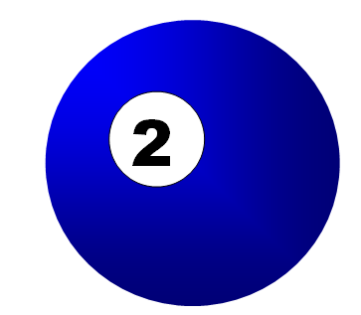

(c) 10 marks

2. Graphic Skills 20 marks
Use the file elephant.bmp or copy the picture included.
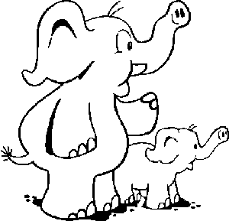

Save this file as XXELE.bmp, replacing XX with your initials. Now make the following changes to image:
- Colour the small elephant pink
- Colour the large elephant green
- Colour all their toenails red
- Make the large elephants tusk blue
- Add blue spots all over the small elephant
- Add another small elephant exactly the same as the existing
one on the left side of the large elephant.
- Remove the trunk from the original small elephant.

3. Graphic Creation 20 marks
Use your graphics package to create a poster advertising a ‘limited collector plate’ according to the following minimum specifications:

Save this file as XXPLATE, replacing XX with your initials.

- The size of image is 400 by 400 pixels, with the plate centred as shown
- The following text must appear on the poster
“Limited Edition Collector Plate - Fish by Night ”
- The plate is shaded with a gradient fill and will give the effect of a star filled evening sky
- The edge of the plate is gold
- At the top of the plate is a graphic of the moon, created by you.
In the centre of the plate is the graphic, FISHY.JPG, which is shown below.
(f) Colour this fish in your school colours and give the fish a shadow.



4. Olympic Advert (20 marks)

In the lead up to the Olympics a local newspaper is running a competition offering its readers the chance to compete in a race at the official Olympic venue against some great Aussie legends.

Your task is to create a newspaper advertisement like the one shown. Make sure that you adhere to the following guidelines:

- The advertisement is 20cm wide and 10cm high.
- The title ‘run against Aussie legends’ is white on black.
- The graphic (bottom left corner) should be any appropriate graphic/clipart.
- The text below the title should wrap around the graphic.
- The question should be in bold.
- The fill-in coupon should have a border as shown.
- The newspapers address should be in bold.
- The layout of the advertisement should be as in the sample.
- Add your name in the bottom right hand corner of the advertisement.
- Spell check your document.
- Save your work as XXADVERT, replacing XX with your initials and print.

Save as: xxx olympic.doc to a folder title AIT2b Marking created by you in the AIT 2b Folder.

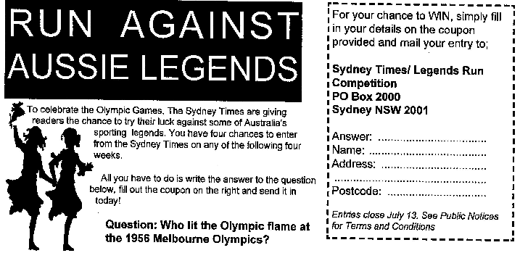

- Create a word document called
xxxevaluation.doc (xxx = your initials) 10 Marks

For each graphic explain how you created the graphic and describe any methods that you used, explain why you chose the software for each graphic and evaluate your own work.

